**WEB-SITE PROJECT PHASE 2**

**Home**

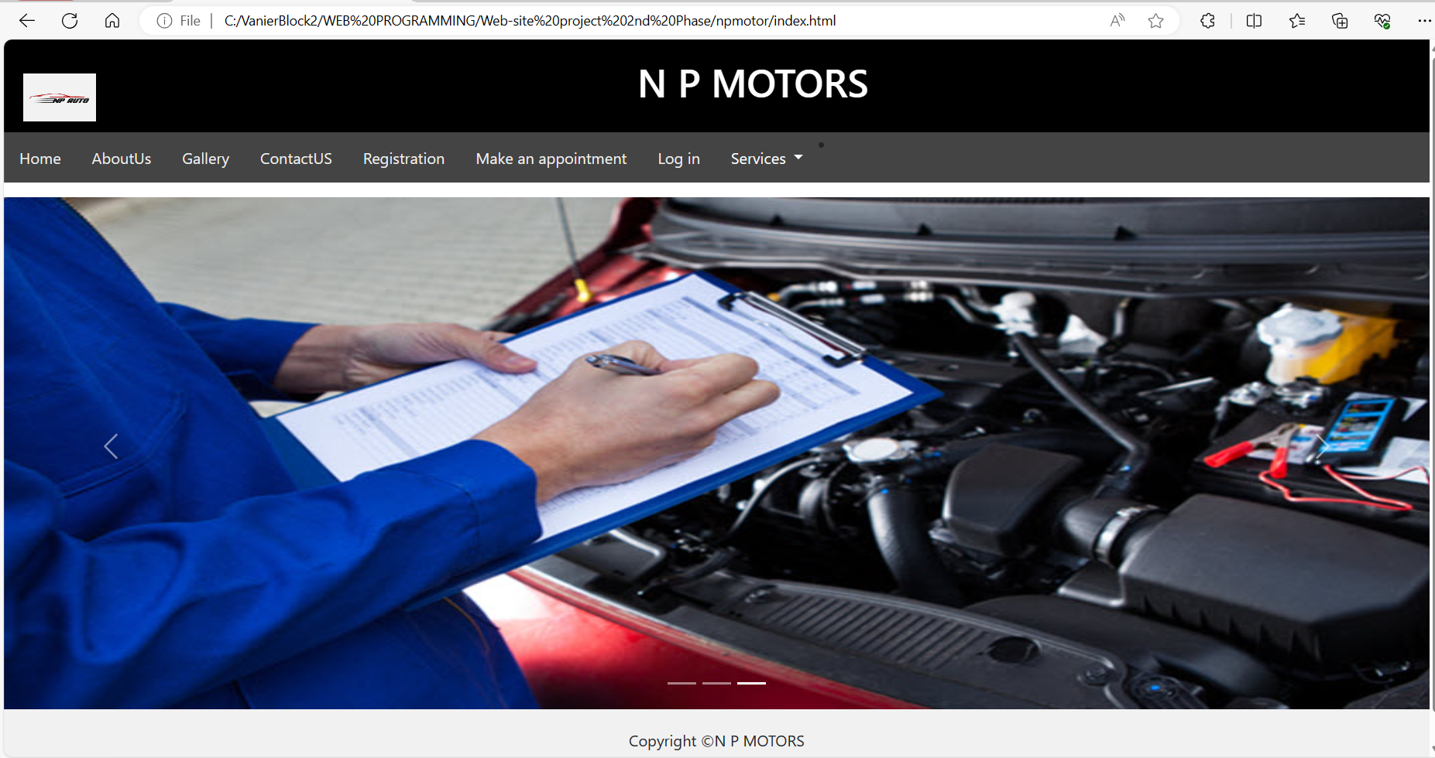

**Aboutus**

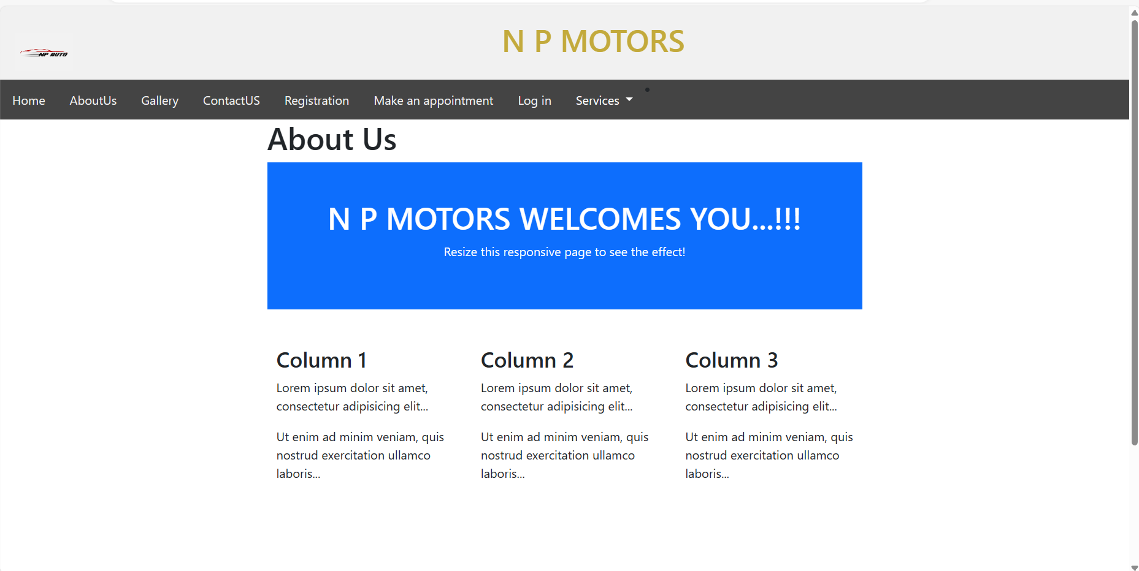

**Gallery: Still pending to adjust size**

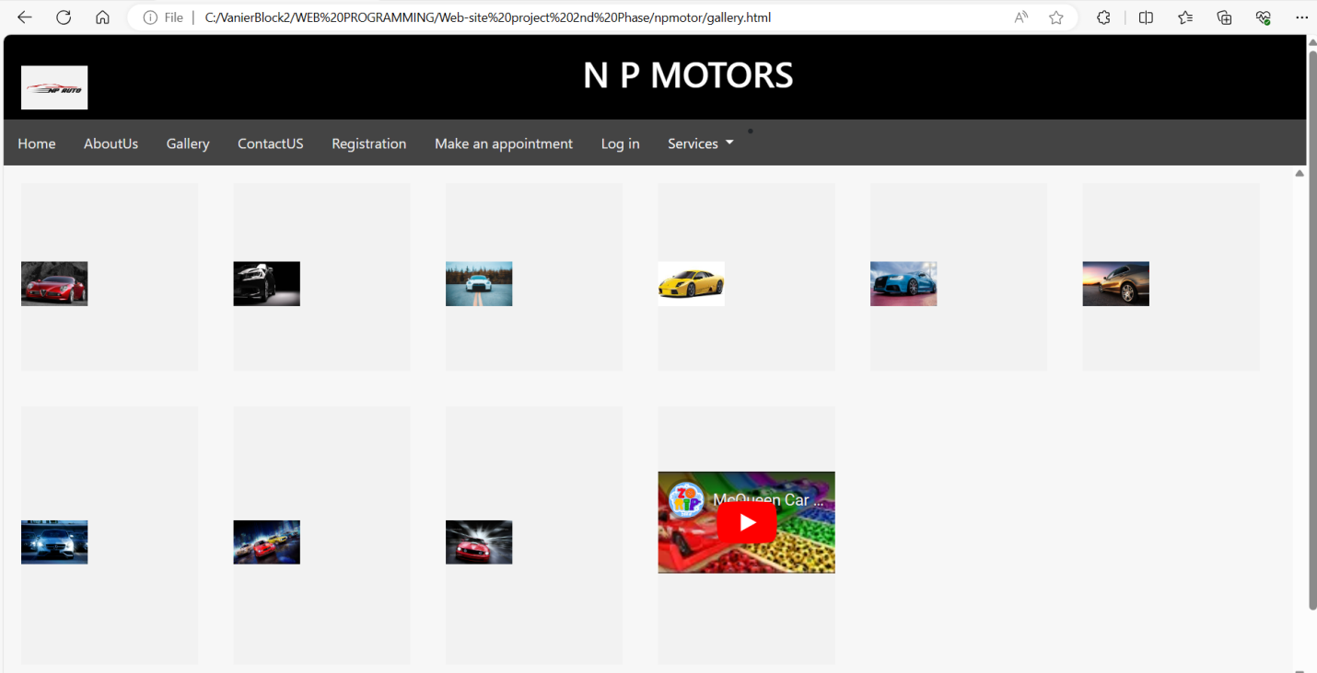

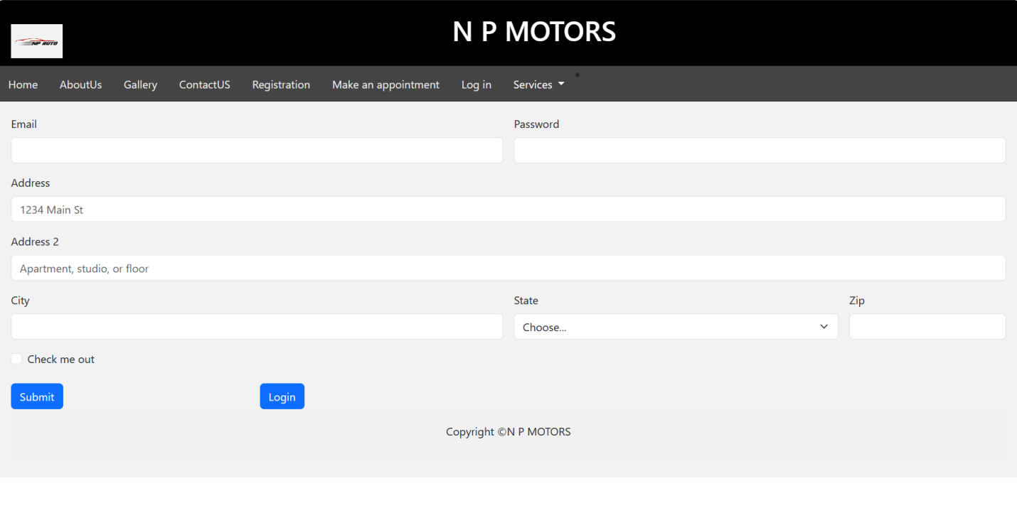

**Registration**

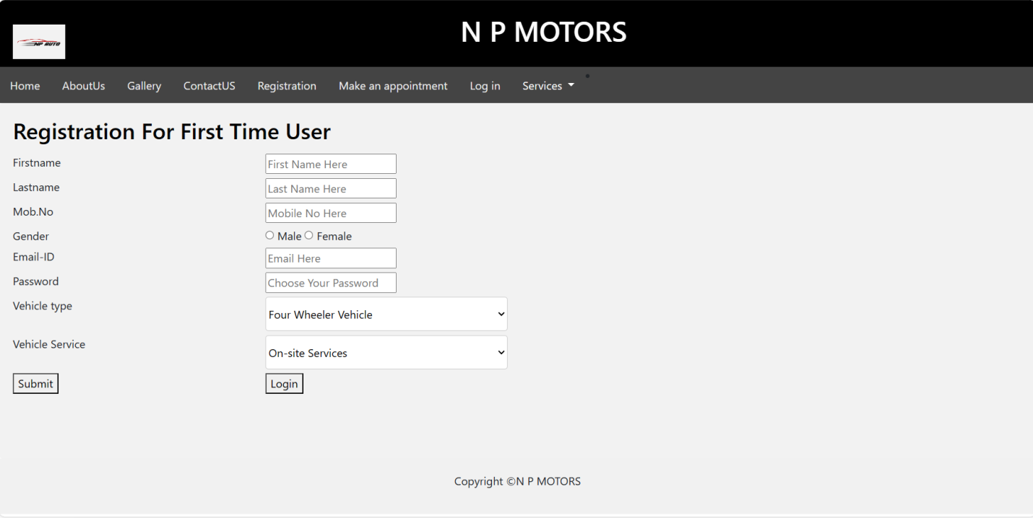

**Appointment**

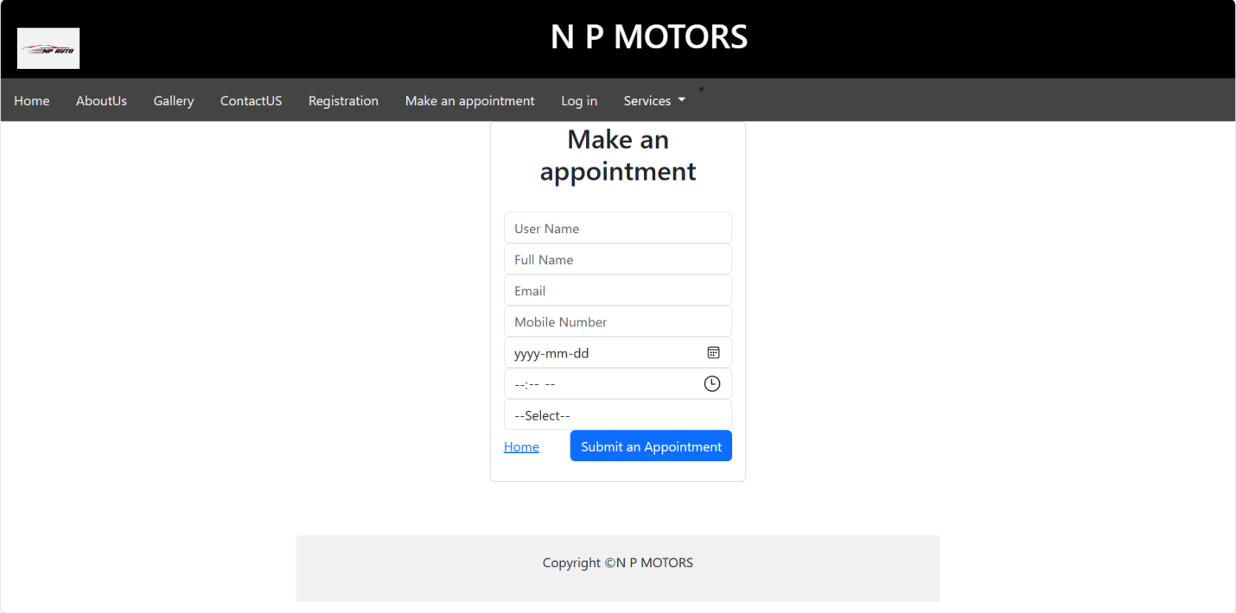

**Login**

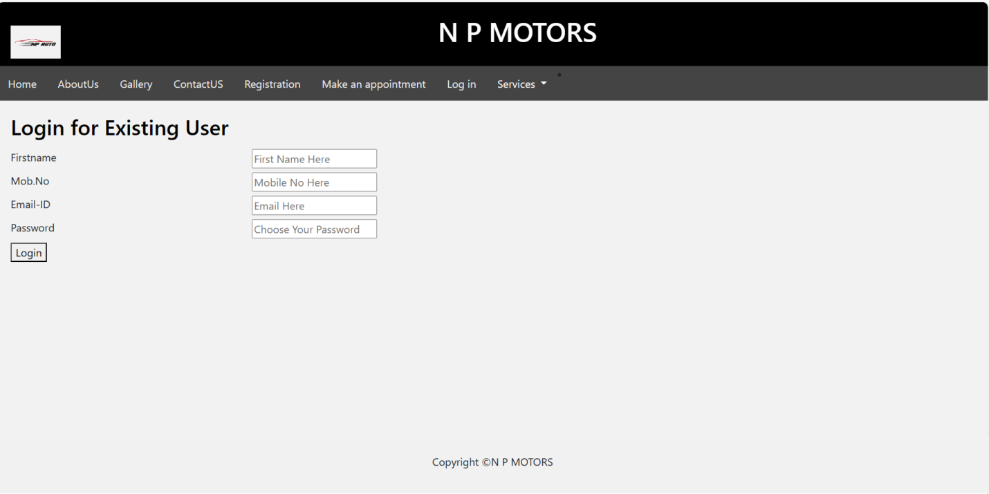

**Price**

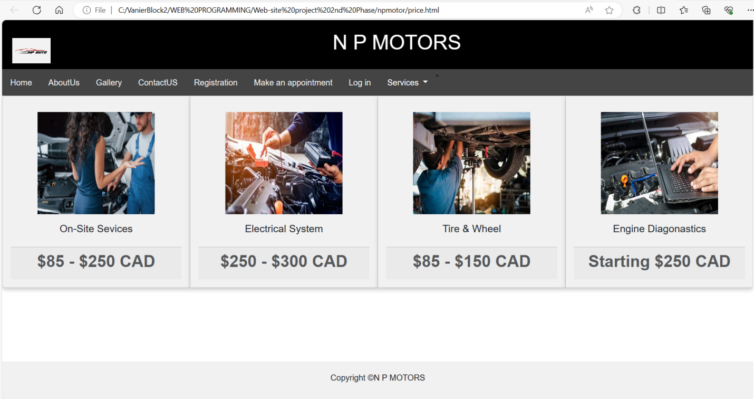

**Still Pending and set-up all the content, I will do that as soon as I will be done with forms.**

**Thanks for understanding**.